**Relational Model**

Organizes data into one or more tables of columns and rows, with a unique key

identifying each row.

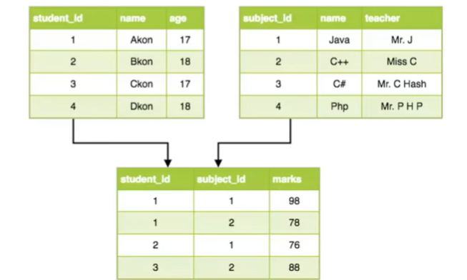

**Relational Database**

It is a digital database based on the relational model of data... a software system

used to maintain relational databases is a relational database management

system (RDBMS)

Common Types of RDBMS

• MySQL

• PostgreSQL

• Oracle

• MSSQL

**The Basics**

1.Database/Schema: Collection of Tables

2.Tables/Relations: A group of rows sharing the same labeled elements

a.Students

b.Subjects

c.Marks

**Advantages of using a Relational Database**

1.Ease of use - SQL

* Ability to do JOINS
* Ability to do aggregations and analytics
* Smaller Data Volumes
* Flexibility of queries

2.ACID transactions - data integrity

S

**When to not use Relational Database**

* Large amounts of Data
* Need to be able to store different data types formats
* Need a flexible schema
* Need high availability
* Need horizontal scalability